|  |  |
| --- | --- |
| Assignment Date | 14 September 2022 |
| Student Name | Neeraja N |
| Student Roll Number | 2019504040 |
| Maximum Marks | 2 Marks |

ASSIGNMENT-1 SMART HOME AUTOMATION

**Circuit Design:**

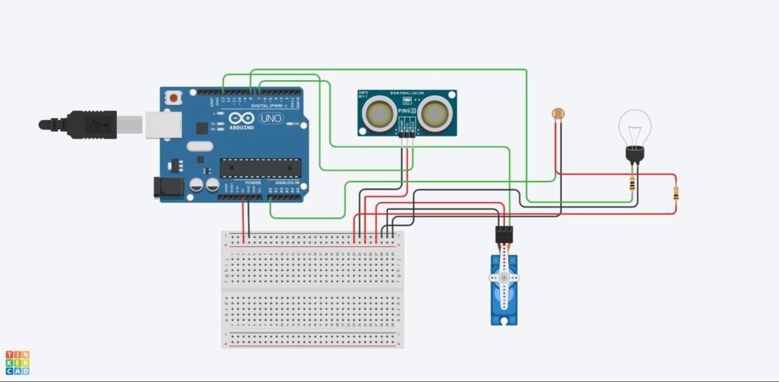

**Source code:**

|  |
| --- |
| #include <Servo.h> |
| int output1Value = 0; |
| int sen1Value = 0; |
| int sen2Value = 0; |
| int const LDR = A0; |
| int USdis(int triggerPin, int echoPin) |
| { |

|  |
| --- |
| pinMode(triggerPin, OUTPUT); |
| digitalWrite(triggerPin, LOW); |
| delayMicroseconds(2); |
| digitalWrite(triggerPin, HIGH); |
| delayMicroseconds(10); |
| digitalWrite(triggerPin, LOW); |
| pinMode(echoPin, INPUT); |
| return pulseIn(echoPin, HIGH); |
| } |
| Servo servo_7; |
| void setup() |
| { |
| Serial.begin(9600); |
| pinMode(A0, INPUT); |
| pinMode(13, INPUT); |
| servo_7.attach(7, 500, 2500); |
| pinMode(8,OUTPUT); |
| } |
| void loop() |
| { |
| int val1 = analogRead(LDR); |
| if (val1 > 90) |
| { |
| digitalWrite(8, HIGH); |
| Serial.print("Bulb OFF = "); |
| Serial.print(val1); |
| } |
| else |
| { |
| digitalWrite(8, LOW); |
| Serial.print("Bulb ON = "); |
| Serial.print(val1); |
| } |
| sen1Value = 0.01723 * USdis(6, 6); |
| if (sen1Value < 100) |
| { |
| servo_7.write(90); |
| Serial.print("Door is Open: Distance = "); |
| Serial.print(sen1Value); |
| Serial.print("\n"); |
| delay(1000); |
| servo_7.write(0); |

|  |
| --- |
| Serial.print("Door is Closed: Distance = "); |
| Serial.print(sen1Value); |
| Serial.print("\n"); |
| } |
| else |
| { |
| servo_7.write(0); |
| Serial.print(" || Door Closed! ; Distance = "); |
| Serial.print(sen1Value); |
| Serial.print("\n"); |
| } |
| delay(10); |